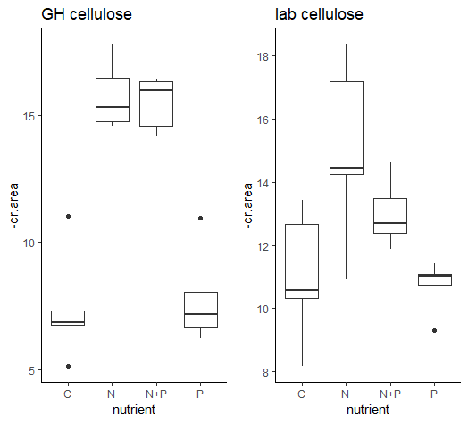

Greenhouse Cellulose Results  
 Df Sum Sq Mean Sq F value Pr(>F)

N 1 323.3 323.3 115.131 1.02e-08 \*\*\*

P 1 0.0 0.0 0.006 0.939

N:P 1 0.6 0.6 0.197 0.663

Residuals 16 44.9 2.8

---

Signif. codes: 0 ‘\*\*\*’ 0.001 ‘\*\*’ 0.01 ‘\*’ 0.05 ‘.’ 0.1 ‘ ’ 1

N limitation

Lab Cellulose Results  
N 1 49.25 49.25 13.566 0.00201 \*\*

P 1 6.72 6.72 1.851 0.19247

N:P 1 3.62 3.62 0.996 0.33304

Residuals 16 58.08 3.63

N limitation

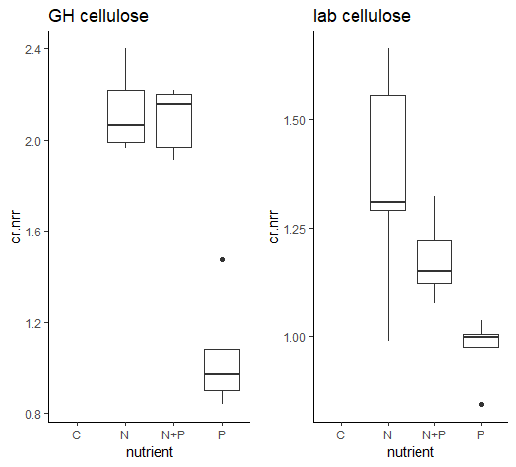

NRR pattern GH, P different than N, P different than N+P

NRR pattern Lab, P different than N

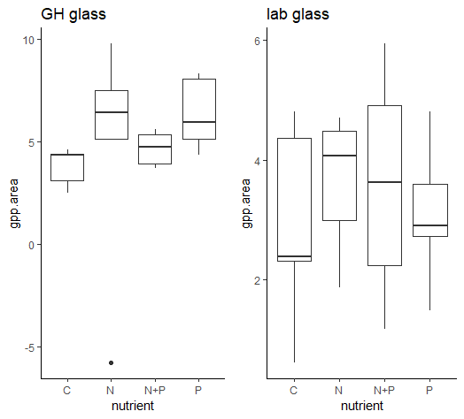

No limitation in either Lab or GH

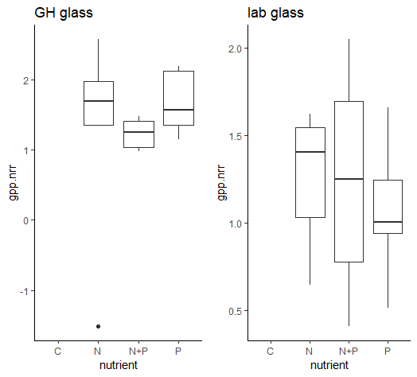

No different among nutrients

CWU results suggest different temperature yield similar Nutrient limitation status results and similar NRR patterns